**Serialization and Deserialization steps using JAVA API:**

<<All relevant files are uploaded in Java_Avro.zip file on blackboard>>

1. **Defining SCHEMA**- > Created following Patients Schema file i.e. patients.avsc file

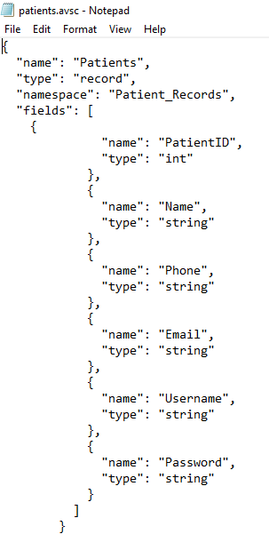

1. **Compiling the schema** 
   1. Download **avro-tools-1.7.7.jar** from <http://avro.apache.org/releases.html>
   2. Created directories Avro_Work. Under that 3 folders jars, schema and with_code_gen. Place jar file and schema files under the respective folders.
   3. Schema folder - > contains schema file

Jar folder -> contains avro-tools-1.7.7.jar file

With_code_gen folder -> After compiling the jar file, a java class file is generated and place under this folder.

* 1. Open cmd and run the following command to generate class file.



* 1. A package according to the namespace specified in the schema will be created after the compilation of command. Within the package, Patients.java file with schema is created under with_code_gen folder.

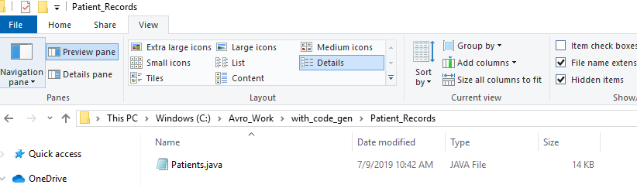

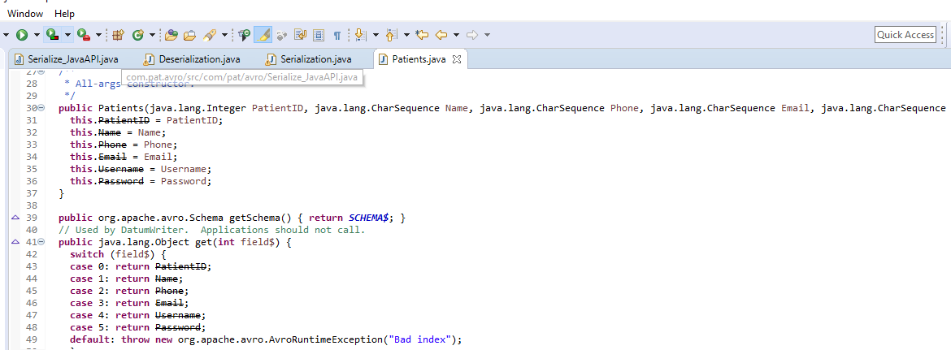

1. **Creating and Serializing the data:**
   1. Instantiate the generated Patients class
   2. Using the set methods, insert data

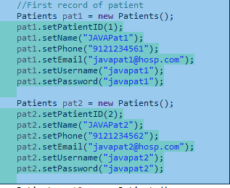

* 1. Create an object of **DatumWriter** interface using the **SpecificDatumWriter** class. This converts Java objects into in-memory serialized format. The following example instantiates **SpecificDatumWriter** class object for **Patients** class.
  2. Instantiate **DataFileWriter** for **emp** class. This class writes a sequence serialized records of data conforming to a schema, along with the schema itself, in a file. Below is code snippet



* 1. Open a new file to store the data matching to the given schema using **create()** method
  2. Add all created records using append method

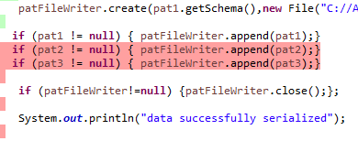

* 1. After executing the file, Patients.avro file is created.

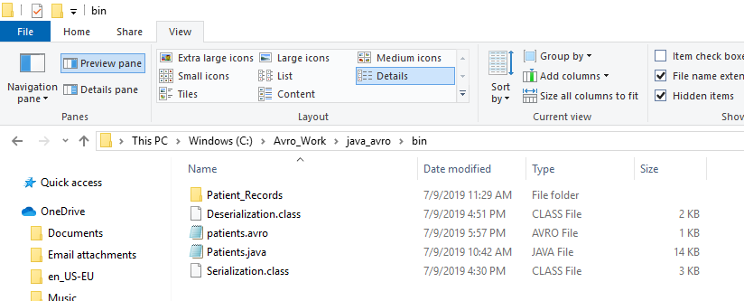

1. **Deserialization by generating class**
   1. Create an object of **DatumReader** interface using **SpecificDatumReader** class.
   2. Instantiate **DataFileReader** for **Patients** class. This class reads serialized data from a file. It requires the **Dataumeader** object, and path of the file where the serialized data is existing, as a parameter to the constructor.
   3. Print the deserialized data, using the methods of **DataFileReader**.

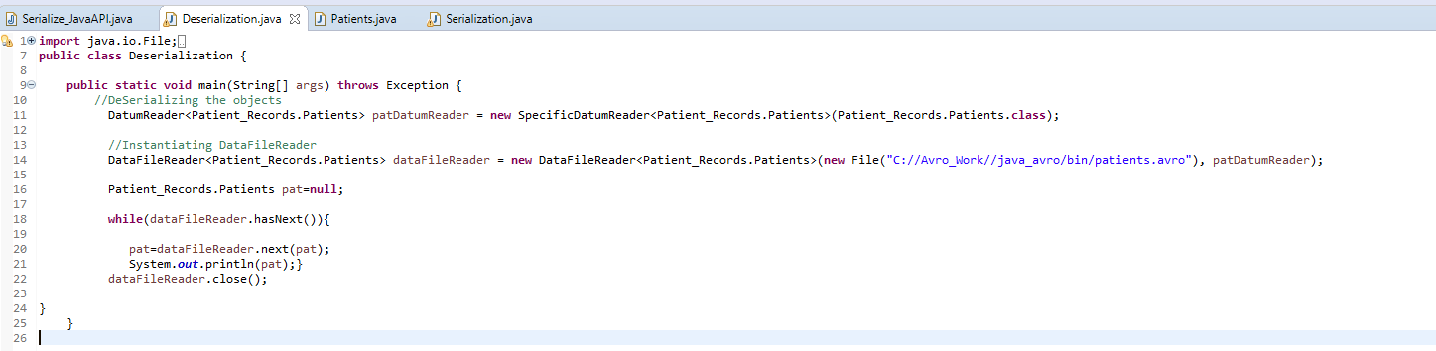

* 1. After executing the class file, following output is generated. Data is deserialized.
  2. 